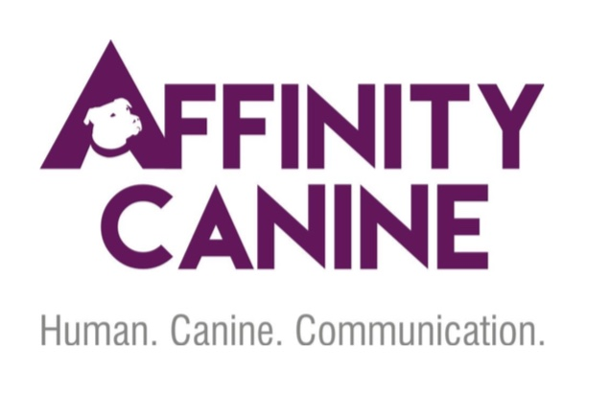

_____________________________________________________________________________________
Boarding Agreement and Release
Affinity Canine, LLC (440)781-6997
abbemoen@gmail.com www.affinitycanine.com
To ensure smooth integration with other services we offer (other boarding clients, training lessons and classes, etc.), drop offs and pickups are available throughout the day by appointment only.
To minimize stress, please bring your dog’s regular food. You may also bring treats for the evening, familiar bedding, a blanket, and/or a crate, and one of your dog’s favorite toys. Please do not bring your dog’s food or water bowls.
All dogs must be up to date on monthly flea, tick, and heartworm preventatives, vaccines, and have a current copy of Rabies, DHLP and Bordetella on file.
Additional services (training sessions, walks, etc.) available upon request.
Please refer to our website, www.affinitycanine.com, for current rates and fees.
Owner’s Information:
First Name: Last Name:
Address:
Home Phone: Mobile Phone: Text: Y / N
Email:
Dog’s Information:
Name: Age: DOB: Breed: Gender: M / F
Spayed/Neutered: Y / N Housetrained: Y / N Crate Trained: Y / N Chew Bedding: Y / N
Type and Brand of Food: Feeding Schedule and Amount:
Additional Feeding Instructions: Dog Treats: Y / N
Veterinary History:
Vet Name/Address/Phone Number:
Flea, Tick Preventative: Y / N Type: Date:
Other Medications Health Issues, Including Allergies:
Emergency Contact and Veterinary Care Release:
Name of Emergency Contact/Relationship Phone:

If my dog is injured, becomes seriously ill, or the state of my dog’s health otherwise requires professional attention while at Affinity Canine LLC, the staff, in its sole discretion, may engage the services of a local veterinarian. I hereby give my consent and authorization to Affinity Canine LLC staff to act on my behalf to transport and obtain veterinary care for my dog. By my signature below, I authorize the veterinarian to provide medical and/or surgical treatment for my dog. I agree to pay for any fees, which may result from said treatment services. Affinity Canine LLC is not liable for the location, treatment or diagnosis of any injuries incurred on our premises. It is recommended you check your dog further or seek treatment for your dog by a licensed veterinarian at your discretion and cost.
Signature: Date:
Client Agreement ***PLEASE READ AND INITIAL EACH ITEM***
____ Affinity Canine LLC reserves the right to immediately change your dog’s type of boarding/training if we believe it is necessary to protect the health and well-being of your dog, other dogs, or our staff.
____ I am welcome to bring my own blankets or toys if desired, however Affinity Canine LLC cannot guarantee that they will be returned in the same condition or at all.
____ The dog is current on all vaccines required by Affinity Canine LLC, and to my knowledge, the dog has not been exposed to rabies, distemper, or other communicable diseases within a 30 day period prior to boarding.
____ I am aware that by leaving the dog at any pet facility, said dog is at a higher risk of contracting canine cough, or other viruses. While we have taken special care in maintaining a high standard of cleanliness and safety, no vaccine is 100% guaranteed.
____ I understand that when dogs play in groups they will get dirty, nicks and scratches, cuts and possibly punctures may occur, as well as any other inherent risks that are involved and I hereby release Affinity Canine LLC of any liability; I further understand and agree that Affinity Canine LLC staff and volunteers will not be liable for any or all problems which may develop.
____ Dogs with flea or tick problems will be treated at the owner’s expense.
____ I understand that I am solely responsible for any harm or damage caused by my dog to persons or property of the Owners, employees and invitees of Affinity Canine LLC, or any other pets housed or visiting Affinity Canine LLC while my dog is attending Affinity Canine LLC Boarding.
____ (optional) Dogs may be videotaped or photographed while attending Affinity Canine LLC. I hereby give my permission to copyright and/or use,reuse and/or publish or post pictures of my dog made through any media by Affinity Canine LLC for use in print material, electronic media or Internet for use in advertising. I release, indemnify, and agree to hold Affinity Canine LLC harmless from any and all manner of damages, claims, loss, liabilities, costs or expenses, causes of actions or suits, whatsoever in law or equity, (including, without limitation, attorney’s fees and related costs) arising out of or related to the services provided by Affinity Canine LLC. I acknowledge and understand that there are certain risks involved in pet ownership, training, and care, including, but not limited to, dog fights, dog bites to humans and/or other pets and the transmission of disease. With my signature below, I understand the risk involved in putting my dog in a boarding environment and acknowledge and accept exclusive and sole responsibility for all medical expenses to said dog no matter the cause. I also authorize the release of said dog’s medical records from the dog’s veterinarian. By signing this contract and leaving my dog with Affinity Canine LLC, I certify to the accuracy of all information given about the dog, that I am the legal owner of said dog, free and clear of all liens and encumbrances and assume financial liability for all payments called for in this agreement. Furthermore, I have read and understand all procedures and policies included herein.
Signature: Date:
Training Agreement (if applicable):
Behaviors to be addressed:
Commands to be covered:
___Sit ___Down ___Heel ___Come ___Place ___Leave it
___No ___Door Control
Program:
___Private Lessons ___2 week stay and train ___3 week stay and train
___4 week stay and train Other

Signature: Date:

